Non-Disclosure Agreement
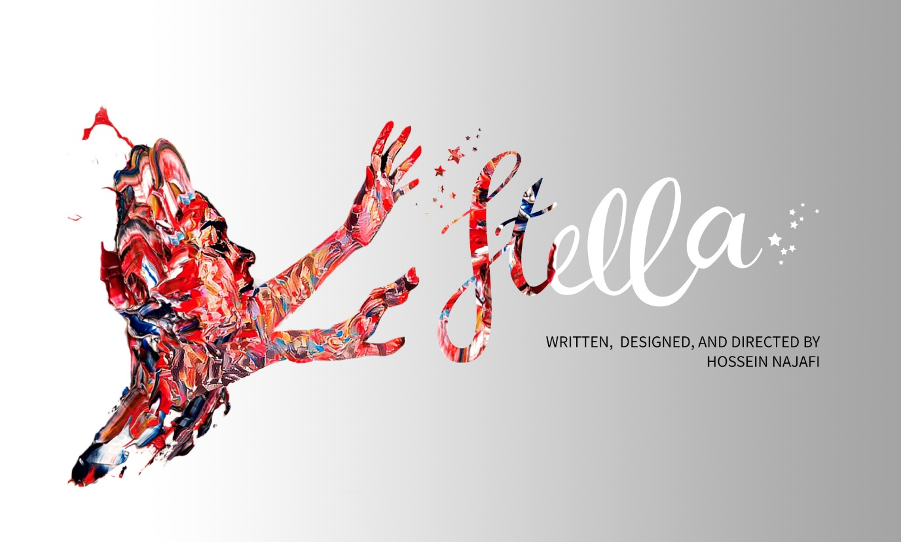

I, the undersigned, understand that while exploring non-paid volunteering and creative matters of mutual interest with Hossein Najafi on the “Stella” project, I will be exposed to confidential information that is not yet available to the public and is therefore sensitive in nature. I therefore agree to hold confidential my exposure to this information until such information is made public knowledge and I receive written permission for using them in my showreel, portfolio or social networking channels. I assert that all the contents that I contribute in creating them are the intellectual properties of Hossein Najafi and I have no right to own, reuse or distribute them. I will be showing the parts I contributed to in my showreel or portfolio after the project release and having the permission. Confidential information shall include all scripts, characters, 3d scenes, content, talent details, video references, storyboards, creative treatments, and all assets shared from the project campaign, and other information disclosed or submitted, orally, in writing, or by any other media. Confidential agreement held between:
Name: ____________________________ Date: _____________
Signature: ____________________________________________
And Name: Hossein Najafi, Date: 22 September 2018
Signature: ____________________________________________

